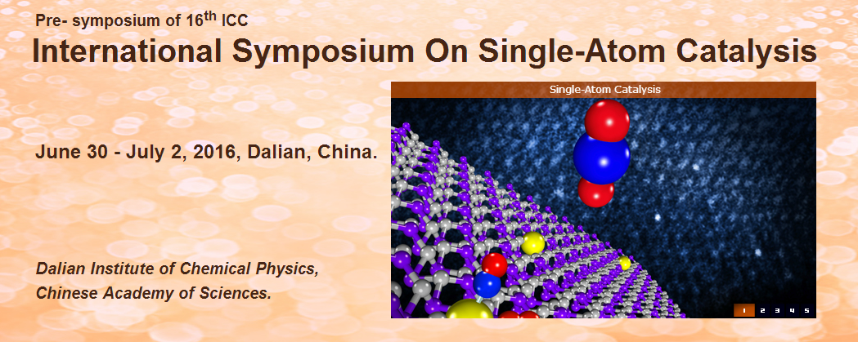

International Symposium On Single-Atom Catalysis
会议时间：2016年6月30日（星期四）— 7月2日（星期六）
会议地点：能源楼会议中心

主办
中国科学院大连化学物理研究所

组委会
主席
张 涛 院士 （中国科学院大连化学物理研究所）
刘景月 教授 （美国亚利桑那州立大学）
李 隽 教授 （清华大学）

日程安排

June 30 (Thursday)
Time | Chair: Can Li
13:30-13:50 | Opening Ceremony
13:50-14:40 | PL-01: Single-atom Platinum and Gold Catalysts Stabilized on Various Supports | Maria Flytzani-  Stephanopoulos
14:40-15:30 | PL-02: Single-atom Catalysts: Concept, Application and Opportunity | Tao Zhang
15:30-15:55 | Photo & Coffee Break
Time | Chair: Nanfeng Zheng & Adam F. Lee
15:55-16:30 | KN-01: Anchoring and Localizing Single Metal Atoms for Better Catalysis | Jingyue (Jimmy) Liu
16:30-16:55 | IT-01: Nanostructured Catalysts for Sustainable Chemical Transformations: from Single Crystal to Single Site | Adam F. Lee
16:55-17:20 | IT-02: Single-Atom Catalysts Achieved by Atomic Layer Deposition | Junling Lu
17:20-17:55 | KN-02: Photochemical Route for Synthesizing Atomically Dispersed Palladium Catalysts | Nanfeng Zheng
18:30 | Reception

July 01 (Friday)
Time | Chair: Abhaya K. Datye & Javier Pérez-Ramírez
08:30-09:20 | PL-03: Isolated Catalytic Sites around the Periodic Table | Peter C. Stair
09:20-09:55 | KN-03: Stable Single-atom Catalysts Based on Graphitic Carbon Nitride | Javier Pérez-Ramírez
09:55-10:20 | IT-03: Structure, Oxidation State, and Chemical Sensitivity of Steps on Anatase (001) Surfaces Decorated with Transition Metal Atoms | Albert Bruix Fusté
10:20-10:40 | Coffee Break & Poster Session
10:40-11:15 | KN-04: Hydrodeoxygenation of Bio-oil Model Molecules and Reduction of Nitric Oxide on Single Site Catalysts | Franklin (Feng) Tao
11:15-11:40 | IT-04: Single-Atom Electrocatalysis in Dye-Sensitized Solar Cells | Y. T. Shi
11:40-12:05 | IT-05: Site-specific FTIR Analysis of Rh and Pt Single Atom Reactivity on Oxide Supports | Phillip Christopher
12:05-12:40 | KN-05: Thermally Stable, Regenerable Single Atom Catalysts via Atom Trapping | Abhaya K. Datye
12:40 | Lunch
Time | Chair: Weixue Li & Konstantin M. Neyman
14:00-14:50 | PL-04: Ménage-à-Trois: Single-atom Catalysis, Mass Spectrometry, and Computational Chemistry | Helmut Schwarz
14:50-15:25 | KN-06: Materials for Single-atom Catalysis Based on Nanostructured Ceria: Density-functional Modelling | Konstantin M. Neyman
15:25-15:50 | IT-06: Role of Single Oxygen Vacancy in Catalytic Conversion of CO₂ | Qingfeng Ge
15:50-16:10 | Coffee Break & Poster Session
16:10-16:45 | KN-07: Dynamic Single-Atom Catalysis (DSAC): Insights from AIMD Simulations | Jun Li
16:45-17:20 | KN-08: First-Principles Study of Hydrogen Production on ZnO Supported Single-atom Catalysts | Weixue Li
17:20-17:55 | KN-09: Generating Active Sites for Olefin Metathesis by Grafting Methyl-trioxo-rhenium on Alumina: A view from DFT calculations | Philippe Sautet
19:00 | Banquet

July 02 (Saturday)
Time | Chair: Andy (Xueliang) Sun & Gareth S. Parkinson
08:30-09:20 | PL-05: Alkane Activation by Modified Oxide Catalysts | Horia Metiu
09:20-09:55 | KN-10: Single Atom Catalysis: An Atomic-Scale View | Gareth S. Parkinson
09:55-10:20 | IT-07: Single-atom Catalyst Supported on Heteropoly Acids | Ning Yan
10:20-10:40 | Coffee Break & Poster Session
10:40-11:15 | KN-11: Size-Selected Clusters as Single-Site Catalysts and Electrocatalysts | Stefan Vajda
11:15-11:40 | IT-08: Colloidal Au Single-atom Catalysts and Their Activities for Aerobic Glucose Oxidation | Haijun Zhang
11:40-12:05 | IT-09: Heterogeneously Catalyzed Cross Coupling Reactions on Gold; Particles vs Atomic Dispersions | Georgios Kyriakou
12:05-12:40 | KN-12: Design of Single Atom Catalysts Using Atomic Layer Deposition Technique for Fuel Cell Applications | Andy (Xueliang) Sun
12:40 | Lunch
Time | Chair: Jingyue Liu & Jun Li
14:00-14:35 | KN-13: Single Atom Alloys for Efficient and Cost-effective Catalysis | E. Charles H. Sykes
14:35-15:10 | KN-14: Catalytic CO Oxidation on Au1 and Pt1 Doped Aluminum Oxide Clusters | ShengGui He
15:10-15:35 | IT-10: Atomically Dispersed Silver Catalysts for Catalytic Oxidation | Xingfu Tang
15:35-15:55 | Coffee Break & Poster Session
15:55-16:45 | PL-06: Efficient Conversion of Methane to Chemicals over Isolated Single Fe Site | Xinhe Bao
16:45-17:35 | PL-07: Metal Oxide-Like MOF Nodes: Oxide Clusters as Supports for Well-Defined Metal Complex Catalysts | Bruce C. Gates
17:35-18:35 | Round Table & Closing Ceremony
18:40 | Dinner

联系人：乔波涛 博士（13478406659）
赵晓晨 博士（18840834096）
主页：http://www.taozhang.dicp.ac.cn/issac/index.html

